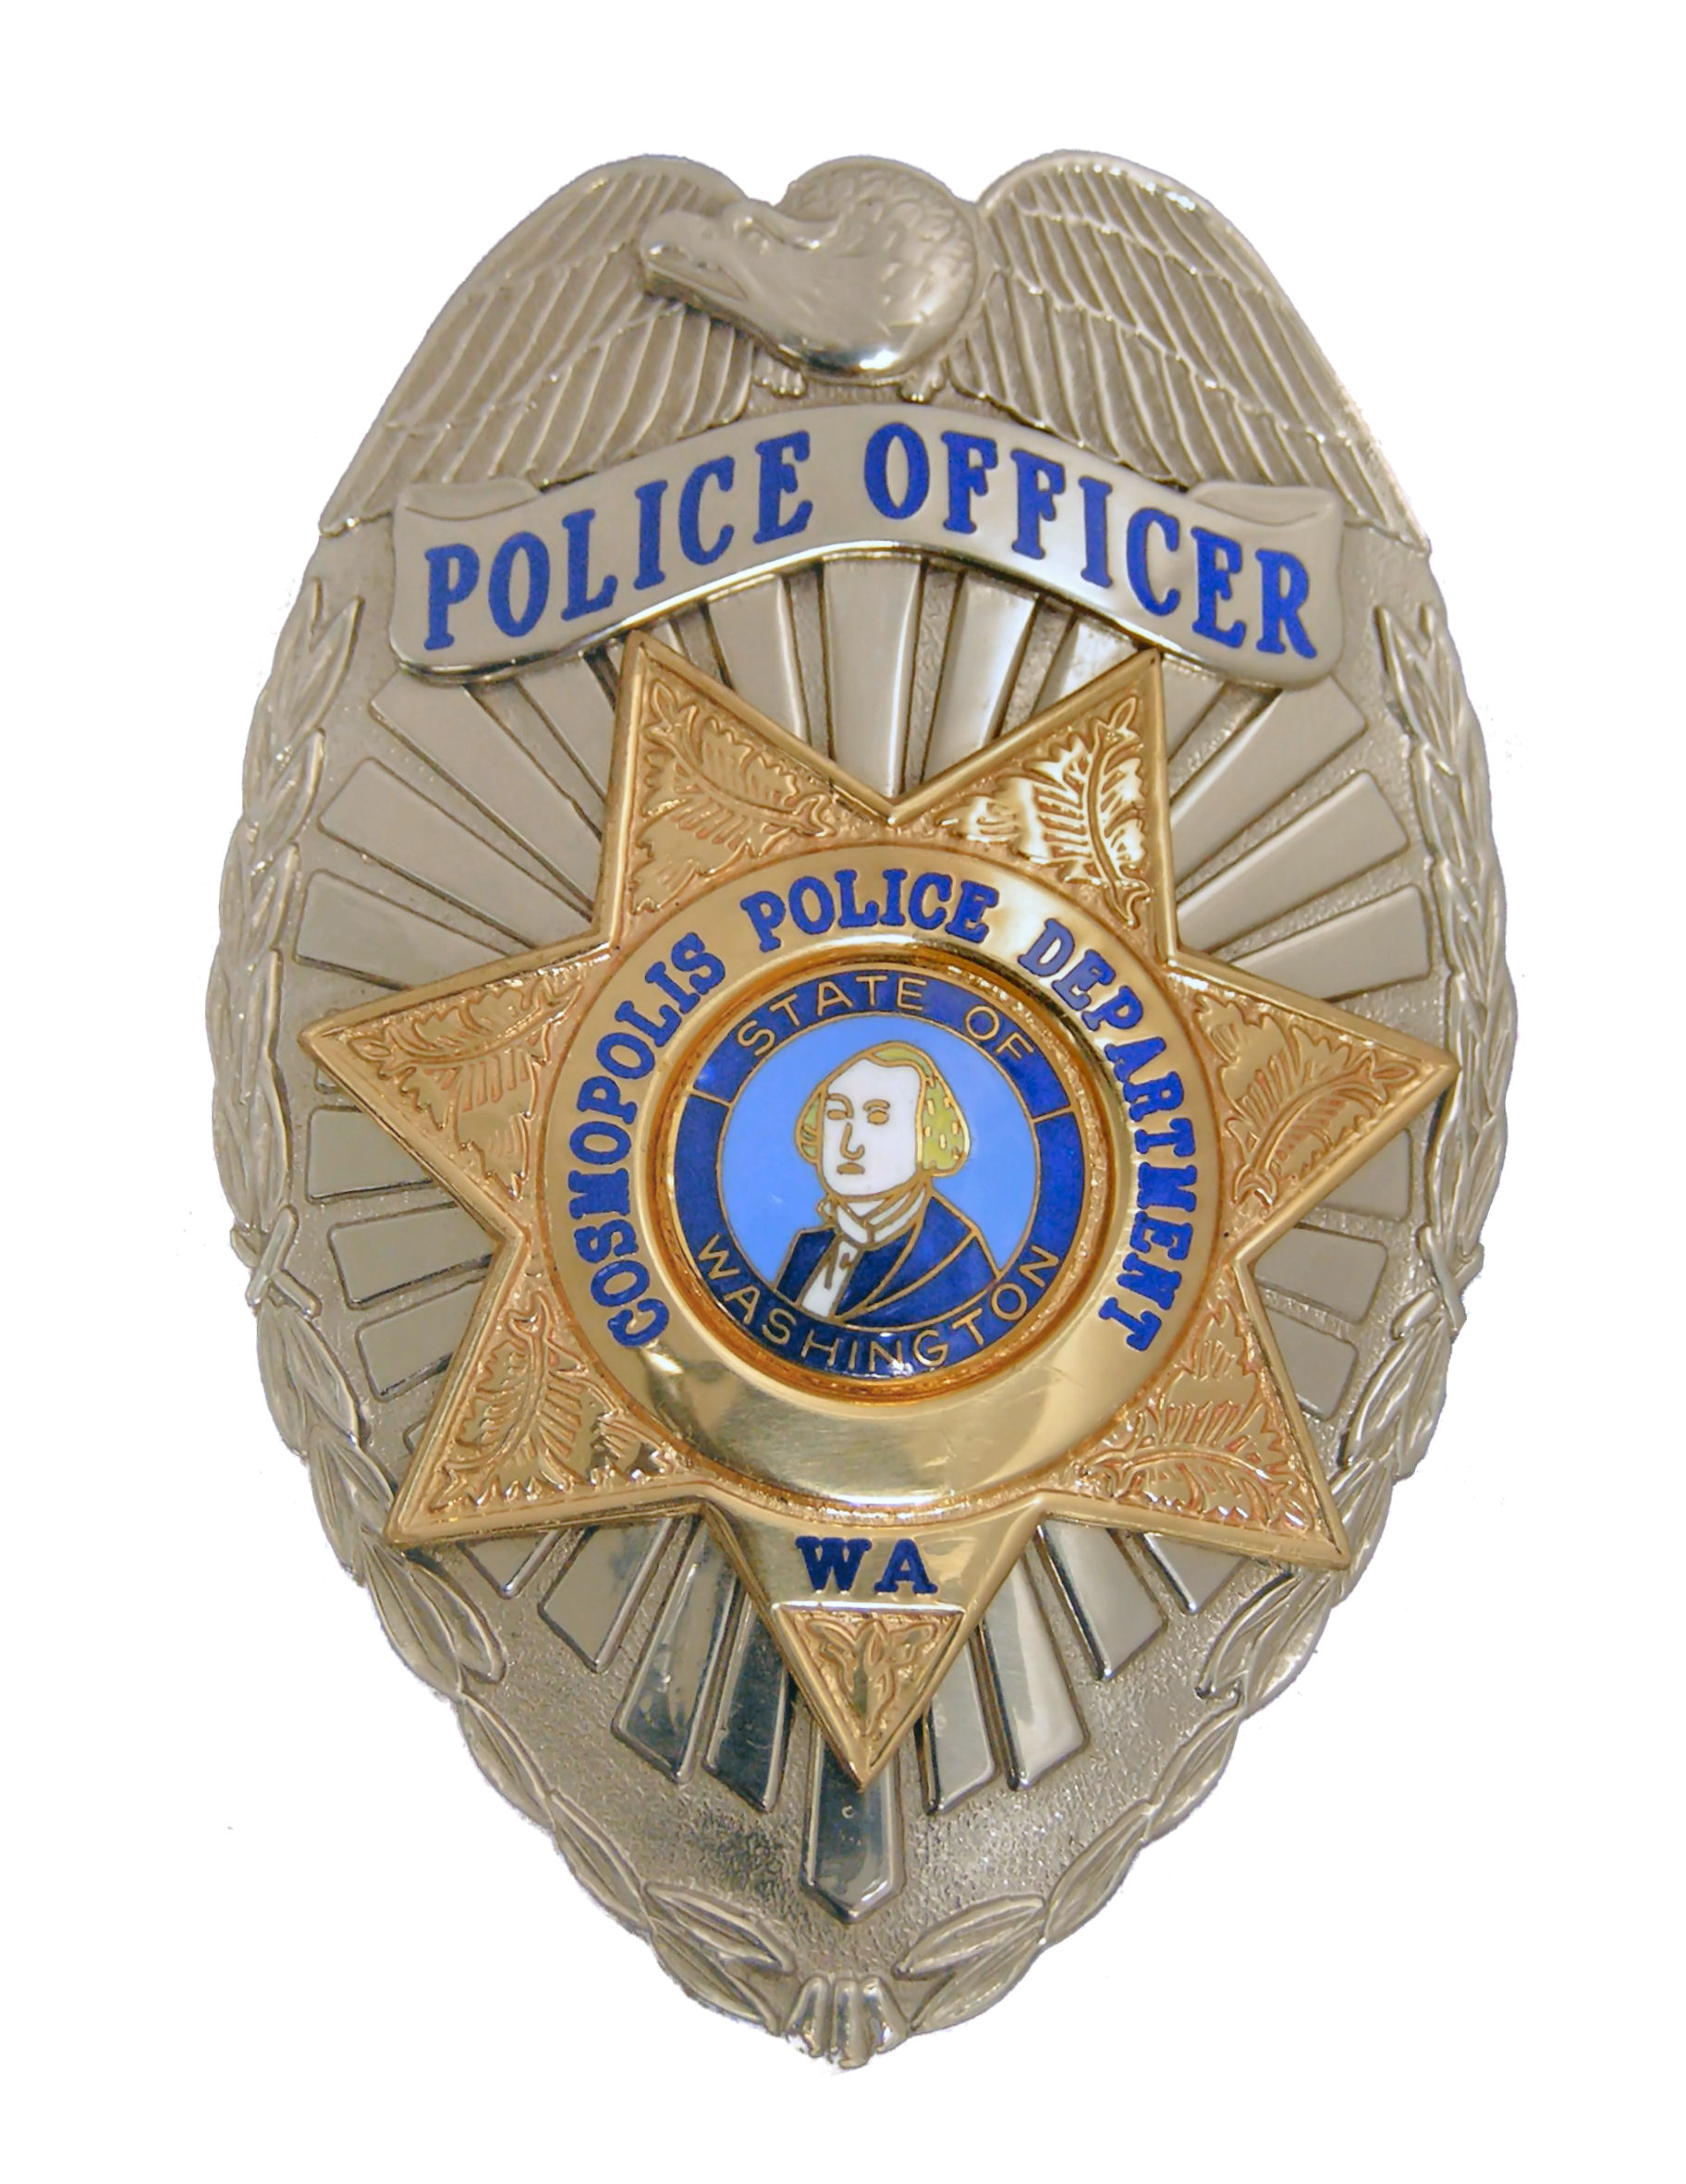 | SECURITY PATROL REQUEST / LOG  COSMOPOLIS POLICE DEPARTMENT  1312 First Street / PO Box 478 Cosmopolis, WA. 98537  Emergency Dial 911 · Office (360) 532-9237· Fax (360) 532-9273

Name: | Phone Number:
Address:

Owner Can Be Reached At: | Departure Date Return Date
Who Can We Contact in Case of Emergency?  Name | Phone #
Address | Do They Have a Key to the Residence? YES NO

Have Lights Been Left ON for Security? YES NO EXPLAIN:
Are Premises Protected by an ALARM? YES NO EXPLAIN (system type):
List Vehicles Left:

*******************************************************************

I REQUEST SECURITY PATROLS OF MY RESIDENCE / BUSINESS DURING THE DATES LISTED ABOVE. FURTHER, I AGREE TO NOTIFY THE POLICE DEPARTMENT IMMEDIATELY UPON RETURN TO CANCEL THIS REQUEST.

SIGNATURE | DATE:

YOUR RESIDENCE / BUSINESS WAS CHECKED ON THE DATES LISTED:
DATE / TIME | OFFICER NAME & NUMBER | COMMENTS REGARDING CHECK

Continue Checks on Back of Form

Form #SECURITY PATROL REQUEST LOG Revised 08-05

